# Installation of VS Code

Installing vs in windows

## Download

Go the to the web browser and go to https://code.visualstudio.com/download

Select version for windows and hit the download button.

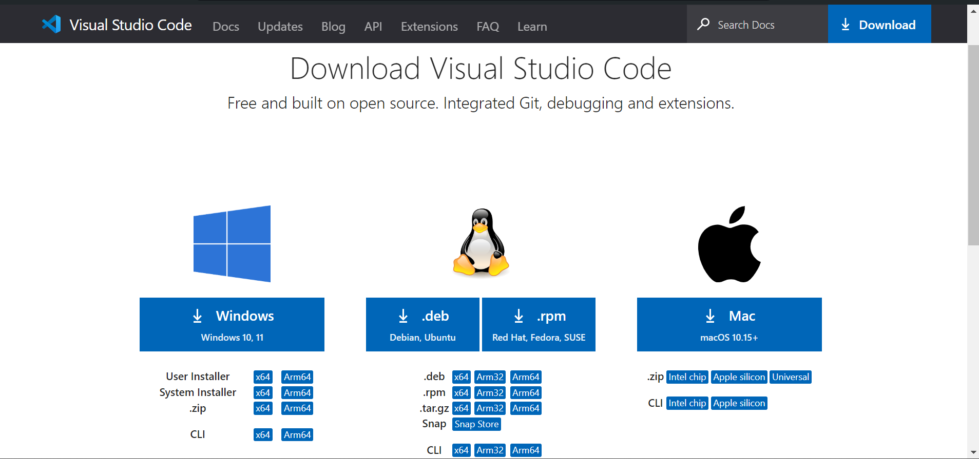

## Run the Installer

Open the file Once the download is complete

## Installation Process

* In the setup wizard, review the license agreement, then click "Next."
* Choose the destination folder where you want to install VS Code, or leave it as the default, then click "Next."
* Choose additional tasks such as creating a desktop icon and adding VS Code to the PATH environment variable, then click "Next."

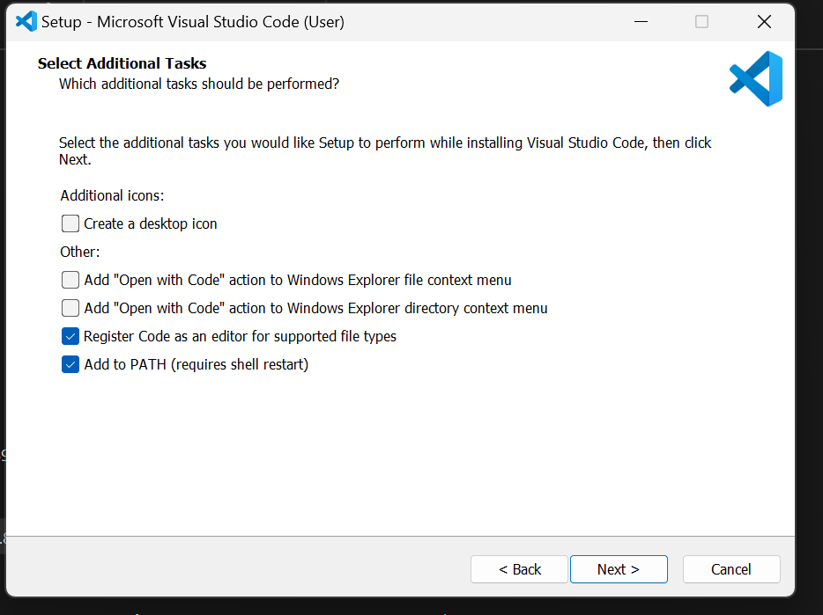

* By default, VS Code is installed under  C:\Users\{Username}\AppData\Local\Programs\Microsoft VS Code.

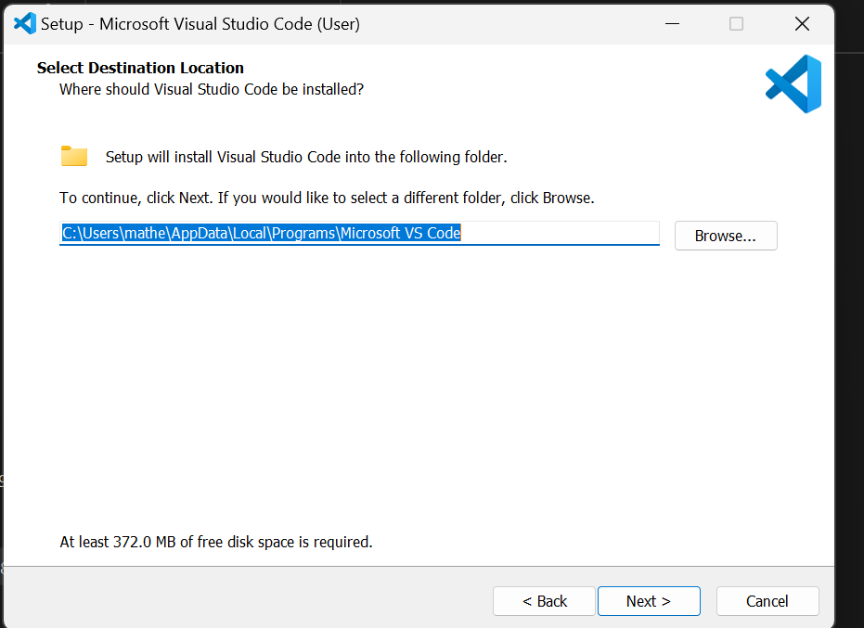

* Click "Install" to start the installation.

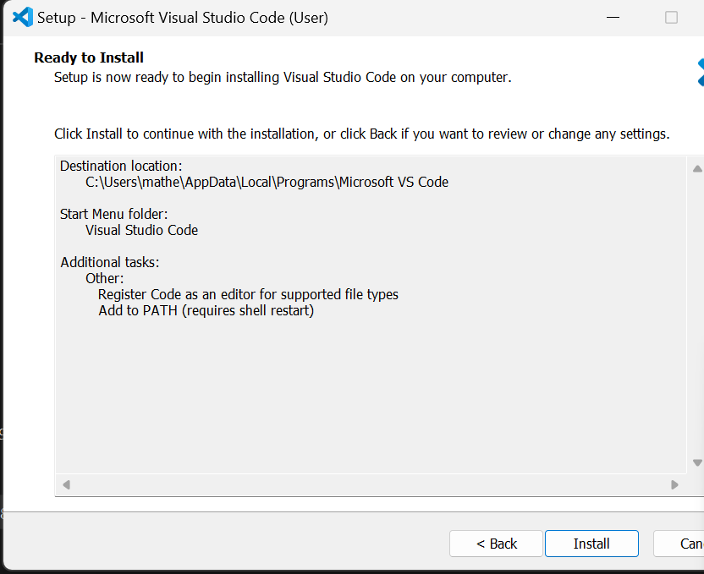

# . First-time Setup

Initial configurations and settings for an optimal coding environment:

1. Theme and Appearance:

- Go to `File > Preferences > Color Theme` to choose a theme that suits your preference (e.g., Dark+ or Light+).

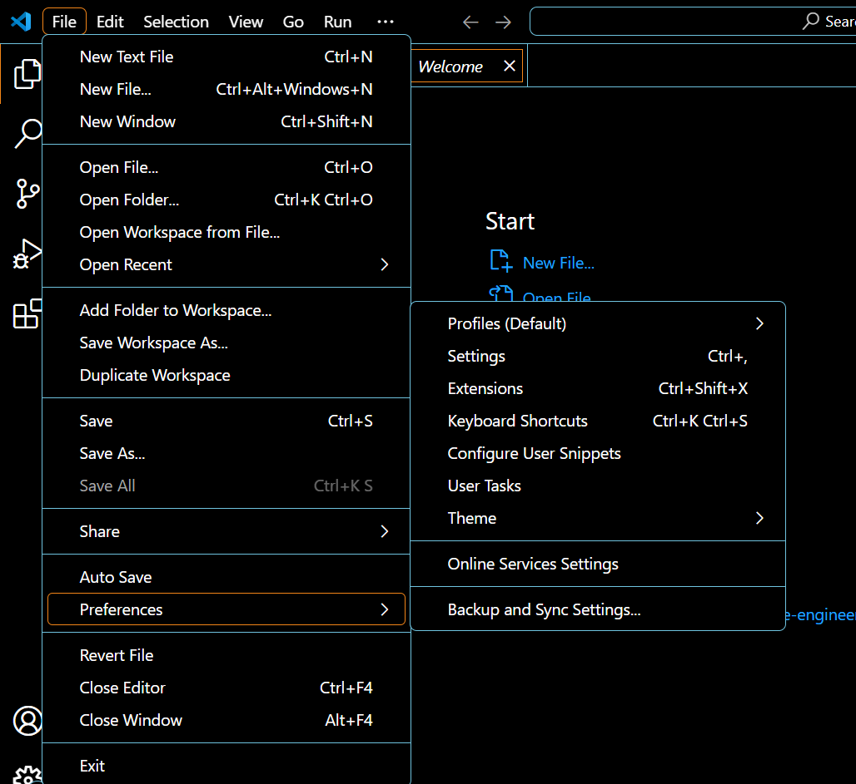

2. Font and Editor Settings:

Open `File > Preferences > Settings` and search for `Font Size` to adjust the text size in the editor.

Adjust `Tab Size`, `Word Wrap`, and `Line Numbers` settings according to your coding style.

# Extensions:

Install essential extensions by clicking on the Extensions view icon in the Activity Bar or pressing `Ctrl+Shift+X`.

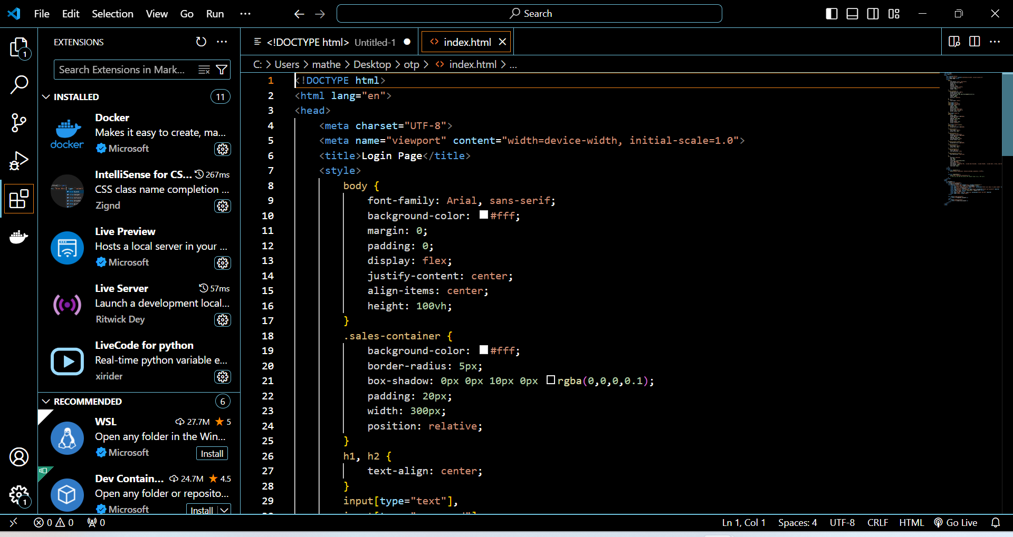

# . User Interface Overview

Main components of the VS Code user interface

1. Activity Bar:

Located on the far left of the window.

Contains icons for different views like Explorer, Search, Source Control, Run and Debug, and Extensions.

2. Side Bar:

Located next to the Activity Bar.

Displays the contents of the selected view (e.g., file explorer, search results).

Allows navigation and interaction with files, folders, and other resources.

3. Editor Group

- The central area where files are opened and edited.

- Supports multiple editors side by side (split view).

- Provides tabs for easy switching between open files.

# Command Palette

A powerful tool in VS Code that provides access to various commands and settings.

Can be accessed by pressing `Ctrl+Shift+P` .

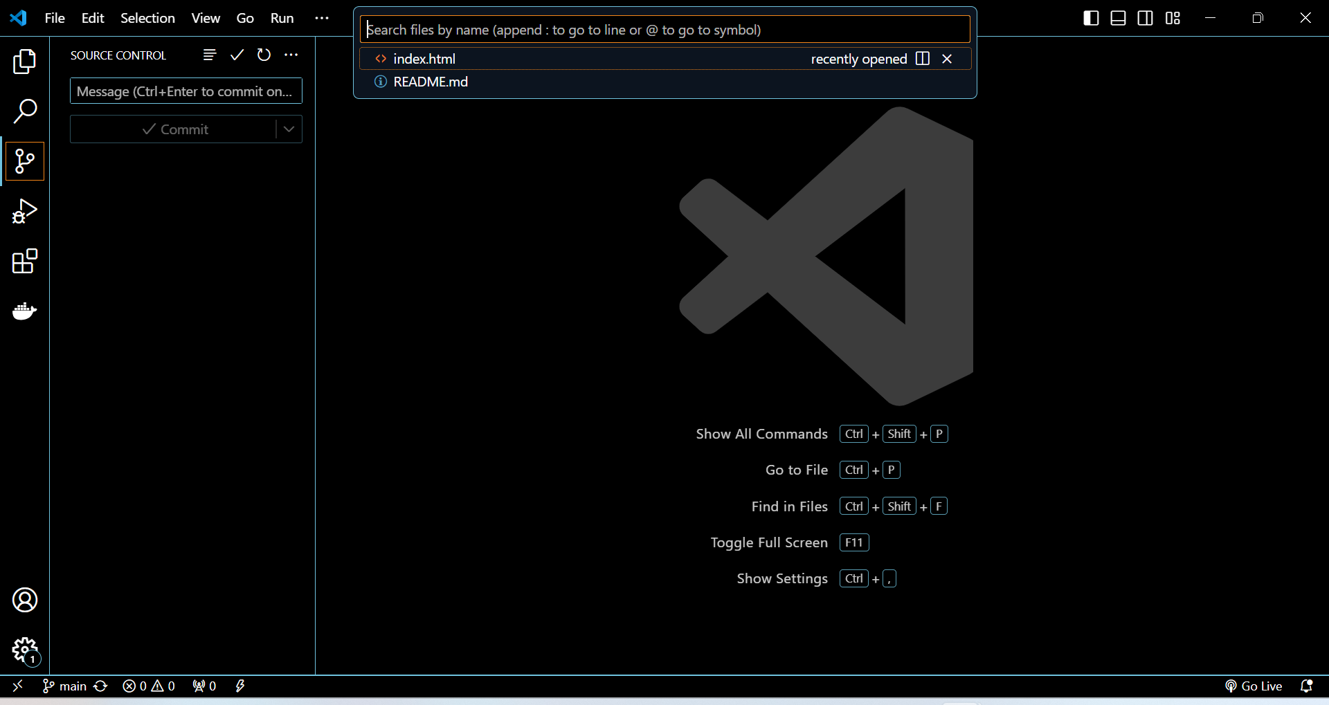

# . Extensions in VS Code

Role of extensions

Enhance the functionality of VS Code by adding new features, languages, debuggers, and tools.

Finding, installing, and managing extensions:

Click on the Extensions icon in the Activity Bar or press `Ctrl+Shift+X`.

* Use the search bar to find extensions.
* Click the "Install" button to add an extension.
* Manage installed extensions from the same view (enable, disable, uninstall).

Essential extensions for web development:

HTML Snippets

CSS IntelliSense

JavaScript (ES6) code snippets

React Native Tools

# Integrated Terminal

Opening and using the integrated terminal

Open the terminal by selecting `Terminal > New Terminal` from the menu or by pressing `Ctrl+`` (backtick).

The terminal opens at the bottom of the window, and you can use it to run shell commands directly from VS Code.

Advantages

Seamless workflow: Execute commands without switching windows.

Integrated environment: Access project files and run scripts in the same interface.

# File and Folder Management

Creating, opening, and managing files and folders:

Create New File/Folder

Right-click in the Explorer view and select `New File` or `New Folder`.

Use `File > New File` or `File > New Folder` from the menu.

open File/Folder

Use `File > Open File` or `File > Open Folder`.

# Navigation

Use the Explorer view for browsing and opening files.

Use `Ctrl+P` to quickly open files by name.

# Settings and Preferences

Finding and customizing settings

Open settings by selecting `File > Preferences > Settings` or by pressing `Ctrl+,`.

Use the search bar to find specific settings.

Customizations iclude

Change Theme:

- Go to `File > Preferences > Color Theme`.

- Change Font Size:

- Search for `Editor: Font Size` in settings and adjust the value.

Change Keybindings

- Go to `File > Preferences > Keyboard Shortcuts` or press `Ctrl+K Ctrl+S`.

9. Debugging in VS Code

Setting up and starting debugging:

1. Open the file containing the code you want to debug.

2. Set breakpoints by clicking in the left margin next to the line numbers.

3. Open the Run and Debug view by clicking on the Debug icon in the Activity Bar.

4. Click the gear icon to create a `launch.json` file if it’s your first time debugging.

5. Choose the appropriate configuration (e.g., Node.js for JavaScript).

6. Start debugging by clicking the green play button or pressing `F5`.

10. Using Source Control

Integrating Git with VS Code

1. Initialize a Repository

- Open the Source Control view by clicking the Git icon in the Activity Bar.

- Click on `Initialize Repository` if you don’t have an existing repository.

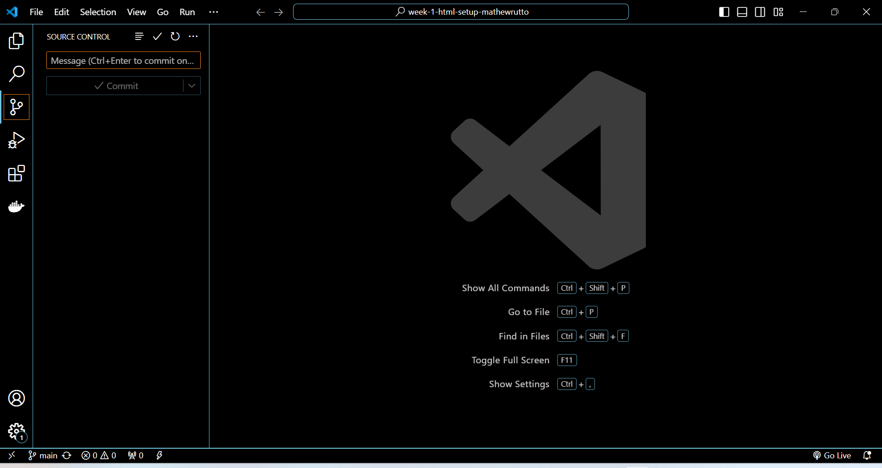

2. Making Commits

- Stage changes by clicking the `+` icon next to the file.

- Enter a commit message and click the checkmark icon to commit.

3. Pushing Changes to GitHub:

- Open the Command Palette (`Ctrl+Shift+P`) and type `Git: Push` to push changes to a remote repository.

- Follow the prompts to authenticate and select the remote repository.